Calculating Family Expenses Using Service Now

Team ID : NM2025TMID01075

Team Size : 4

Team Leader : Akshen S

Team member : Chandru S

Team member : Rathisan R

Team member : Aldrine Jasco S V

**Sub Titles**

* Introduction
* Project Objective
* Setting Up Service Now Instance
* Creation of New Update set
* Creation of Table (Family Expenses)
* Creation of Table (Daily Expenses)
* Creation of Relationship
* Configuring Related List on Family Expenses
* Creation of Business Rules
* Configure the Relationship
* Conclusion

**Introduction**

Calculating Family Expenses Using Service Now

A Guided project was designed to build a clear, flexible, and easy-to-use system for keeping track of and organizing family expenses through the ServiceNow platform.

**Project Objective**

The goal of this project is to build a comprehensive family expenses calculation system that allows users to categorize and record expenses, set budgets, and track them in real time.

It also aims to establish relationships between tables for better organization of data.

**Setting Up ServiceNow Instance**

1. A personal developer instance (PDI) was created from ServiceNow to start building and testing the application.
2. Open "https://developer.servicenow.com".
3. Create a personal developer instance.
4. Click on Request Instance.
5. Submit the request.
6. Navigate to the ServiceNow platform.

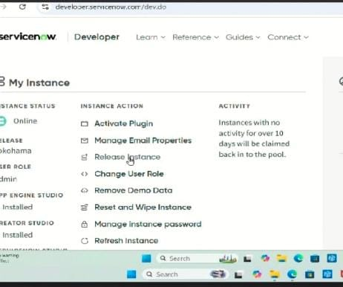

**Creation of New Update Set**

An update set was created to capture all customizations and configurations during the project development.

Click Local Update Set

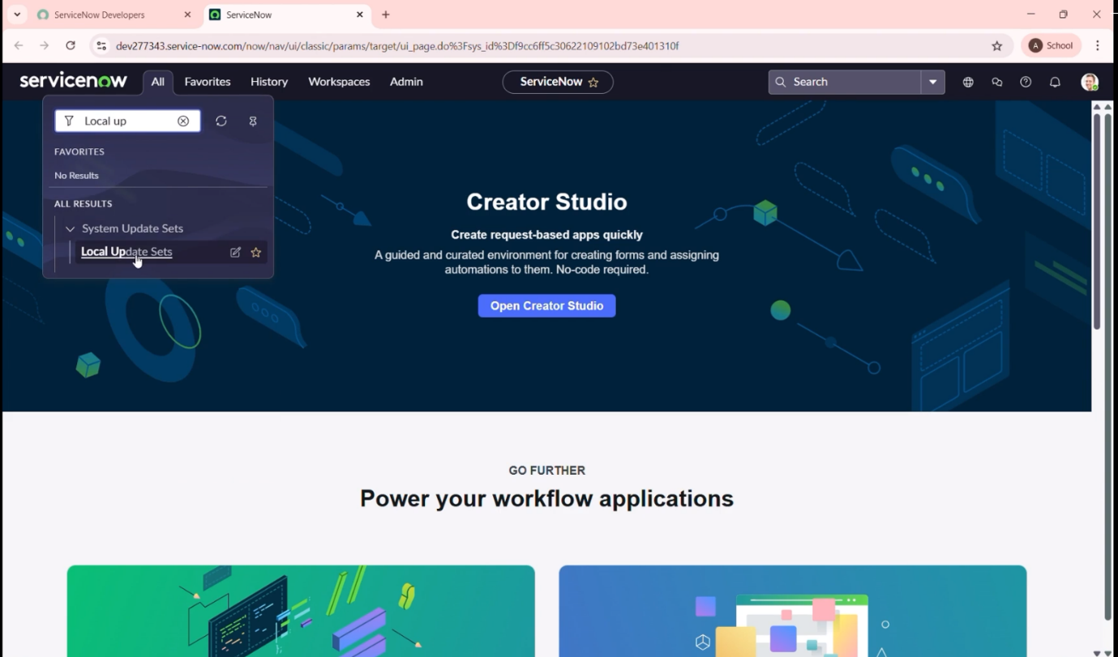

Enter the Details:

Name: Family Expenses, then click Submit.

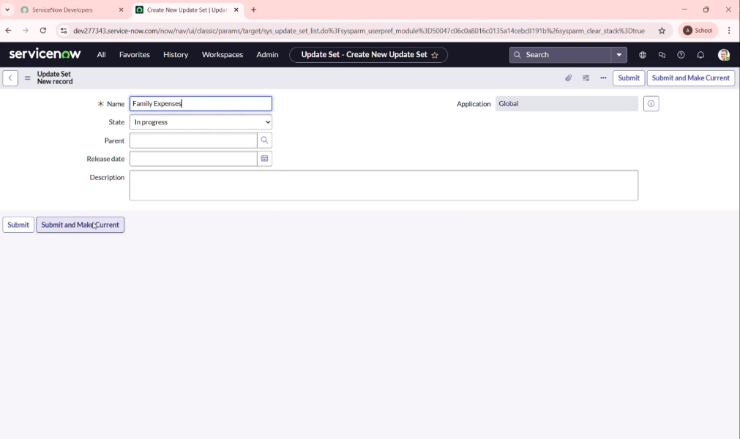

**Creation of Table (Family Expenses)**

A new table was added to store core family expense details such as category, amount, and date.

1. Creation of family expenses table

a. Search for tables and click New.

b. Label: Family Expenses

Name: Auto – Populated

New menu name: Family Expenditure

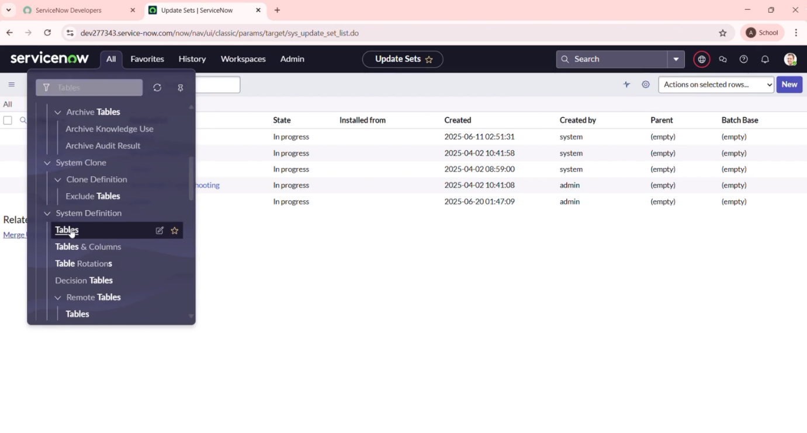

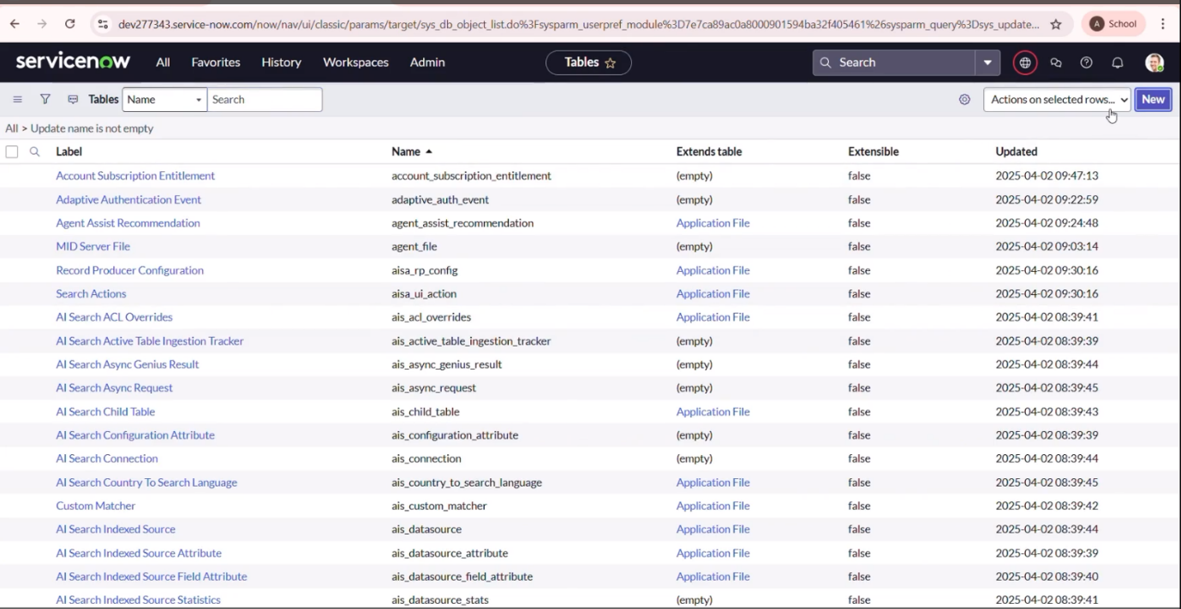

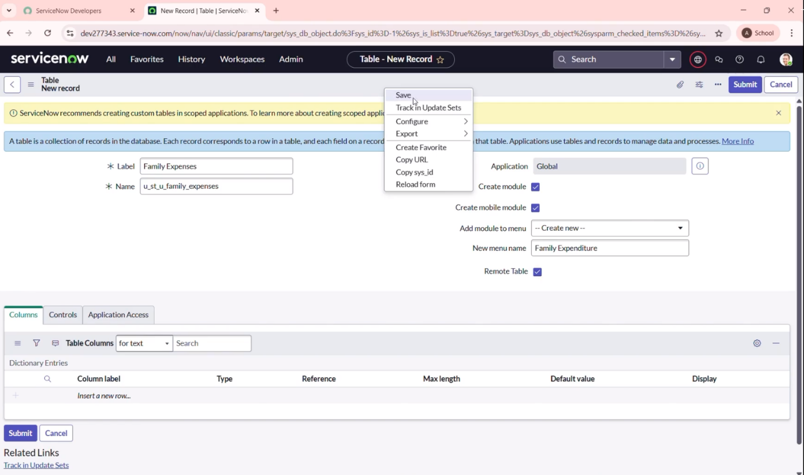

c. Go to the header, right-click, and click Save.

2.Creation of Columns (Fields)

1. Insert a new row
2. Column label: Number

Type: String

1. Column label: Date

Type: Date

1. Column label: Amount

Type: Integer

1. Column label: Expense Details

Type: String

Max length: 800

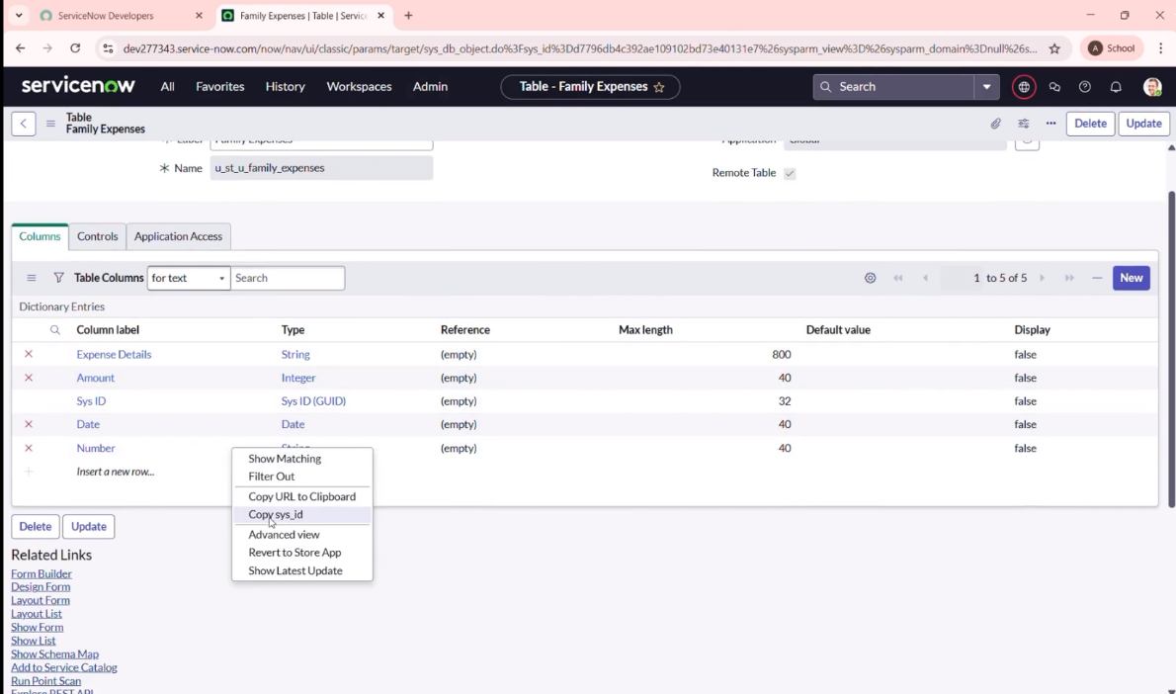

3. Making Number Field An auto – Number

a. Double-click the Number field.

b. Click on Advanced view

c. Click Default value

Use dynamic default: checks the box

Dynamic default value: Get Next Padded Number

d. Click Update button

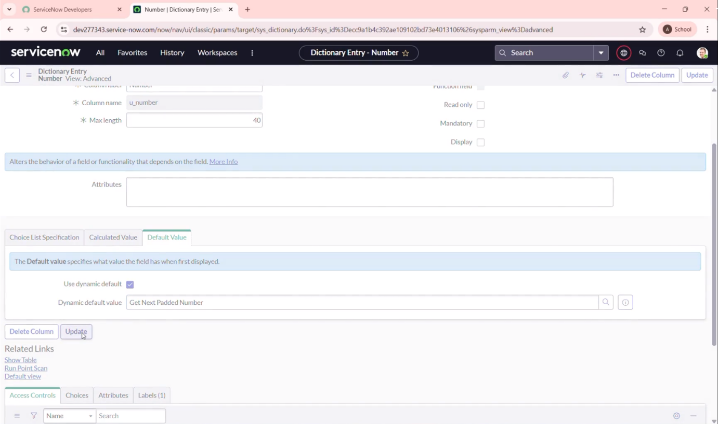

e. Go to all – search number maintenance select “Number Maintenance”

f. Click on new

g. Table: Family Expenses

Prefix: MFE

h. Click on “Submit” button

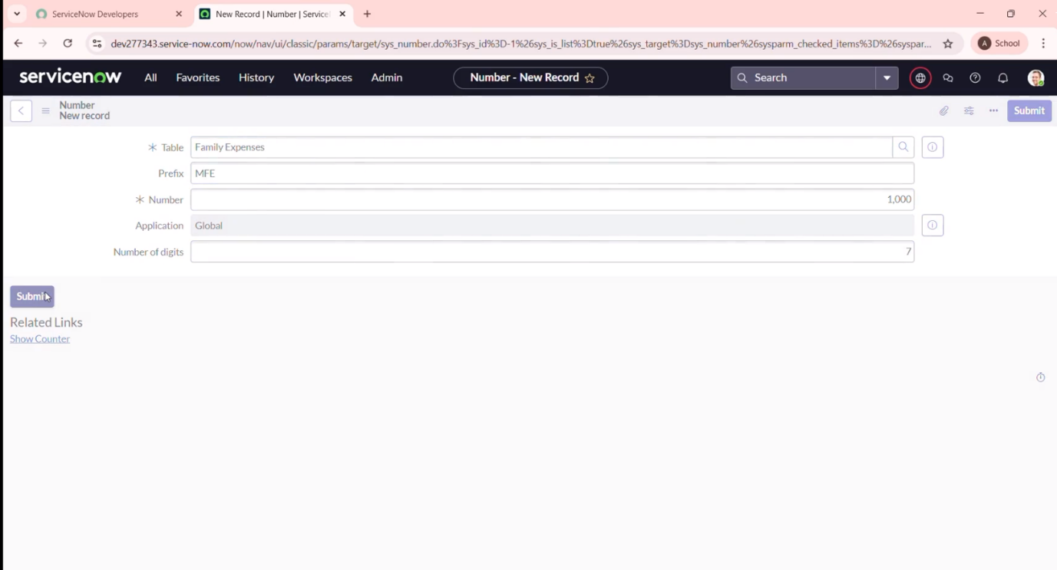

4. Configure The Form

a. Search for Family Expenses and open it.

b. Click New

c. Go to the Header >> Right click >> click on configure select from design

d. Make the Number field read-only by clicking the gear icon and checking "Read-Only."

e. Make Date and Amount mandatory fields by checking the mandatory option.

f. Click save

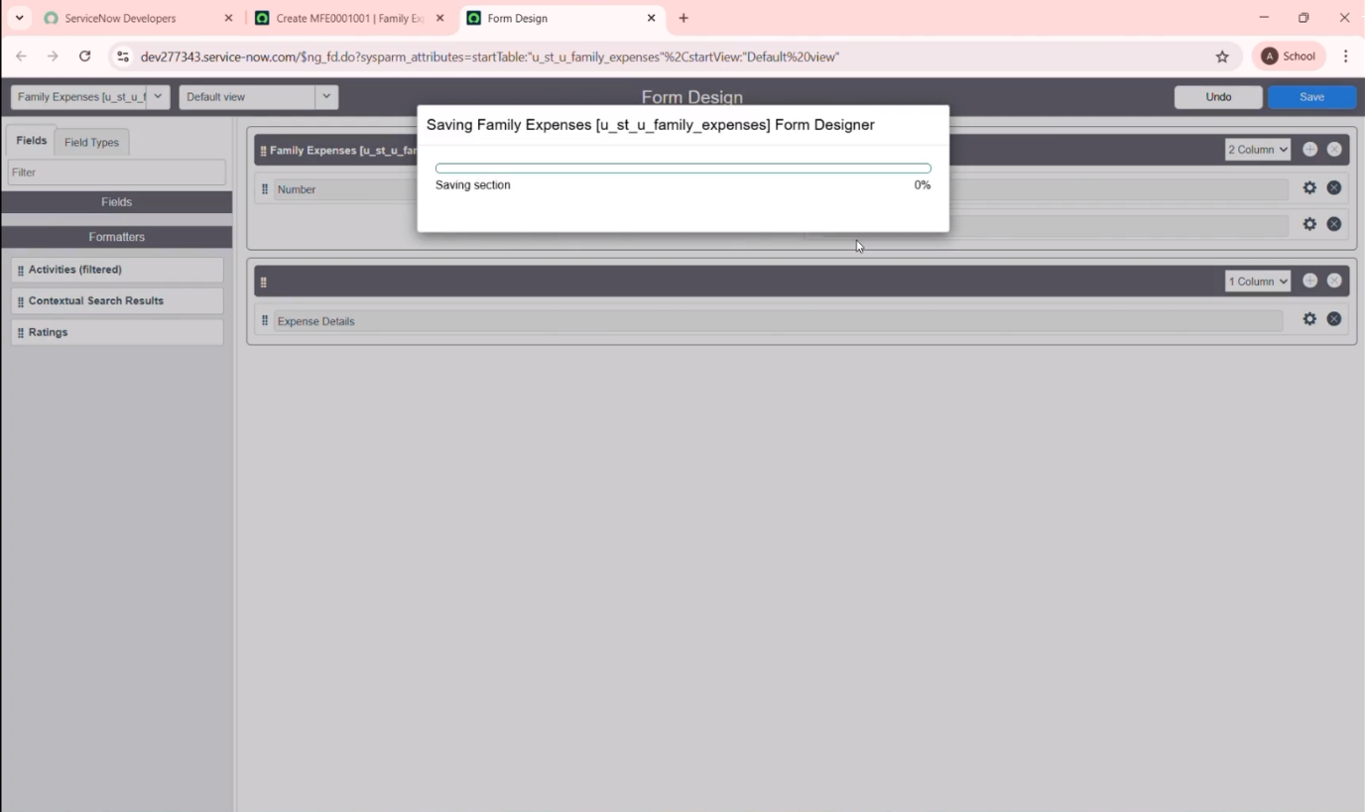

**Creation of Table (Daily Expenses)**

A related table was created to record individual daily expense entries linked to the main family record.

1. Creation of daily expenses table

a. Go to All >> search “Tables” >> click new

b. Enter the details

Label: Daily Expenses

Name : Auto – Populated

Add Module to menu : Family Expenditure

e. Click save

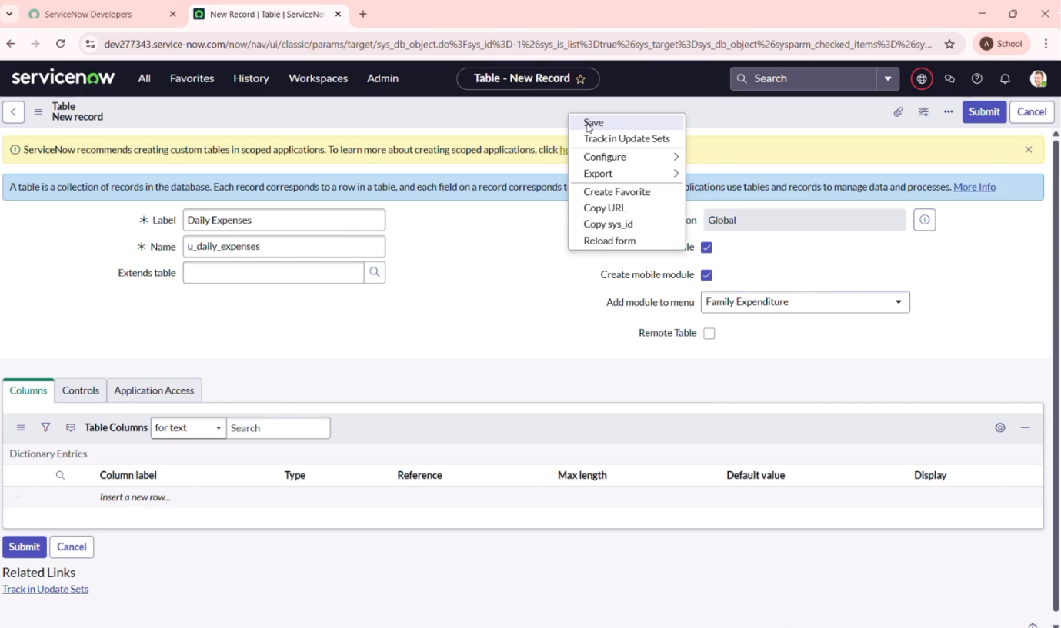

2. Creation of Columns (Fields)

a. Insert a new row for each column.

b. Column label: Number

Type: String

c. Column label: Date

Type: Date

d. Column label: Expense

Type: Reference

e. Column label: Family Member Name

Type: Reference

Max length: 800

f. Column label: Comments

Type: String

Max length: 800

g. Click on Save

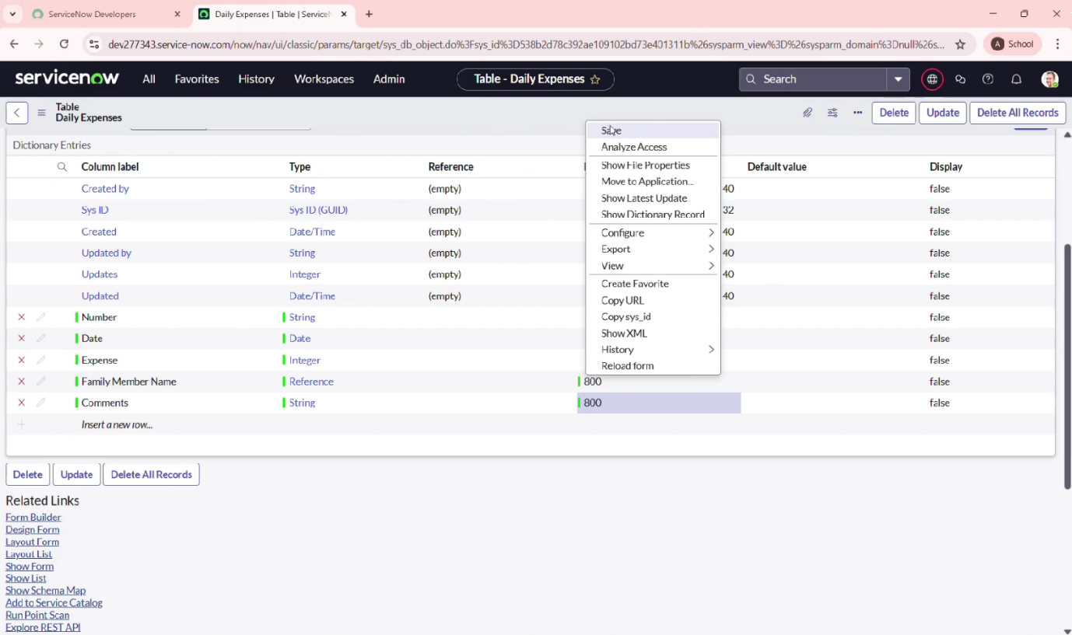

3. Making Number Field an Auto – Number

a. Double click on the number Field

b. Click Advanced View

c. Click Default value

Use dynamic default: checks the box

Dynamic default value: Get Next Padded Number

d. Click Update

e. Go to all >> search for “number Maintenance select number Maintenance

f. Click new

g. Table: Daily Expenses

Prefix: DFE

h. Click on submit

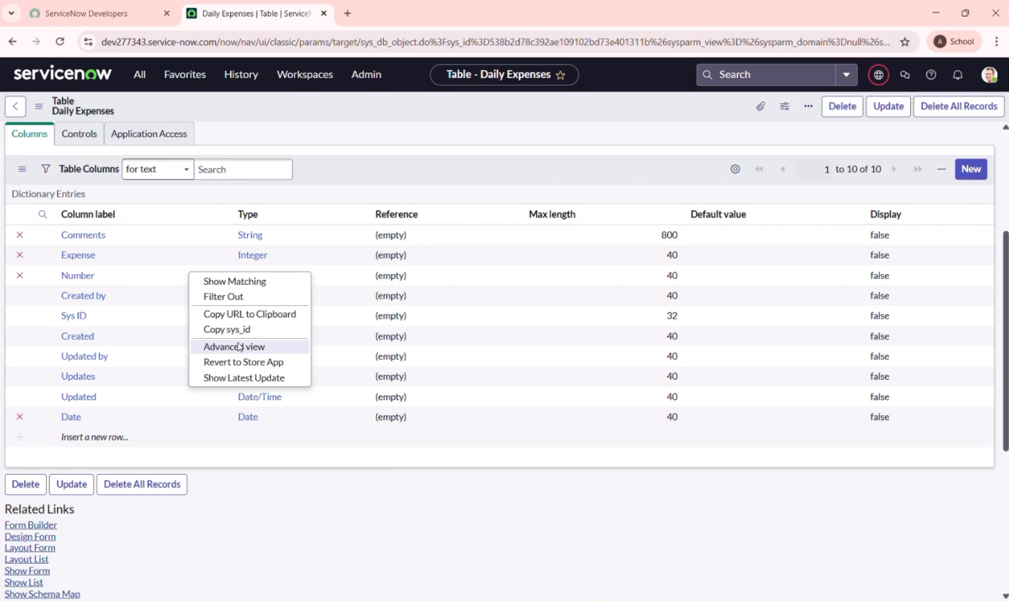

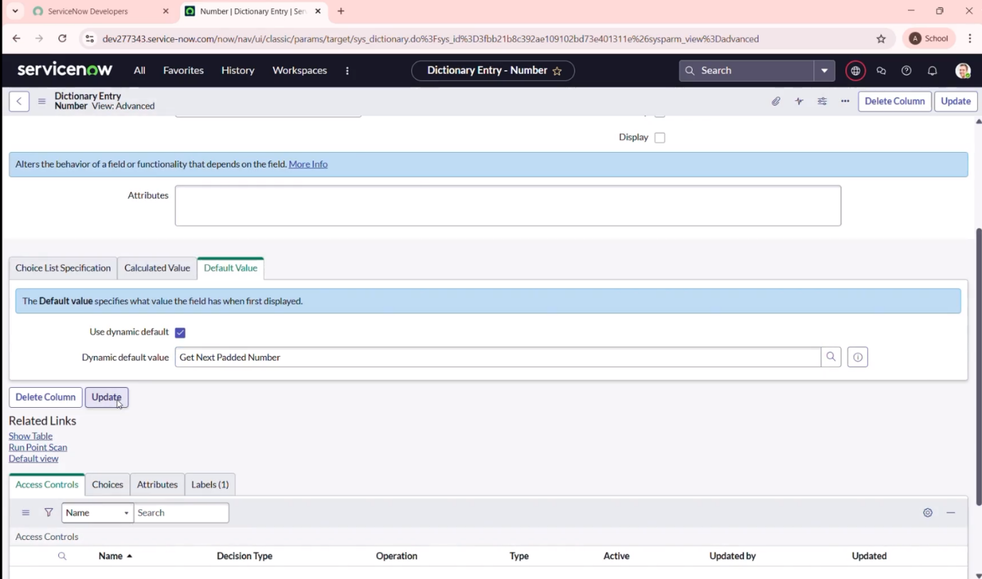

**Creation Of Relationship**

Define the relationship between the Family Expenses and Daily Expenses tables to enable hierarchical tracking.

Creation of relationship between family expenses and daily expenses tables

a. Go to all >> search Relationships >> open relationships

b. Click on New

c. Name : Daily Expenses

Applies to table : Select Family Expenses

Daily Expenses : Select Daily Expenses

d. Click save

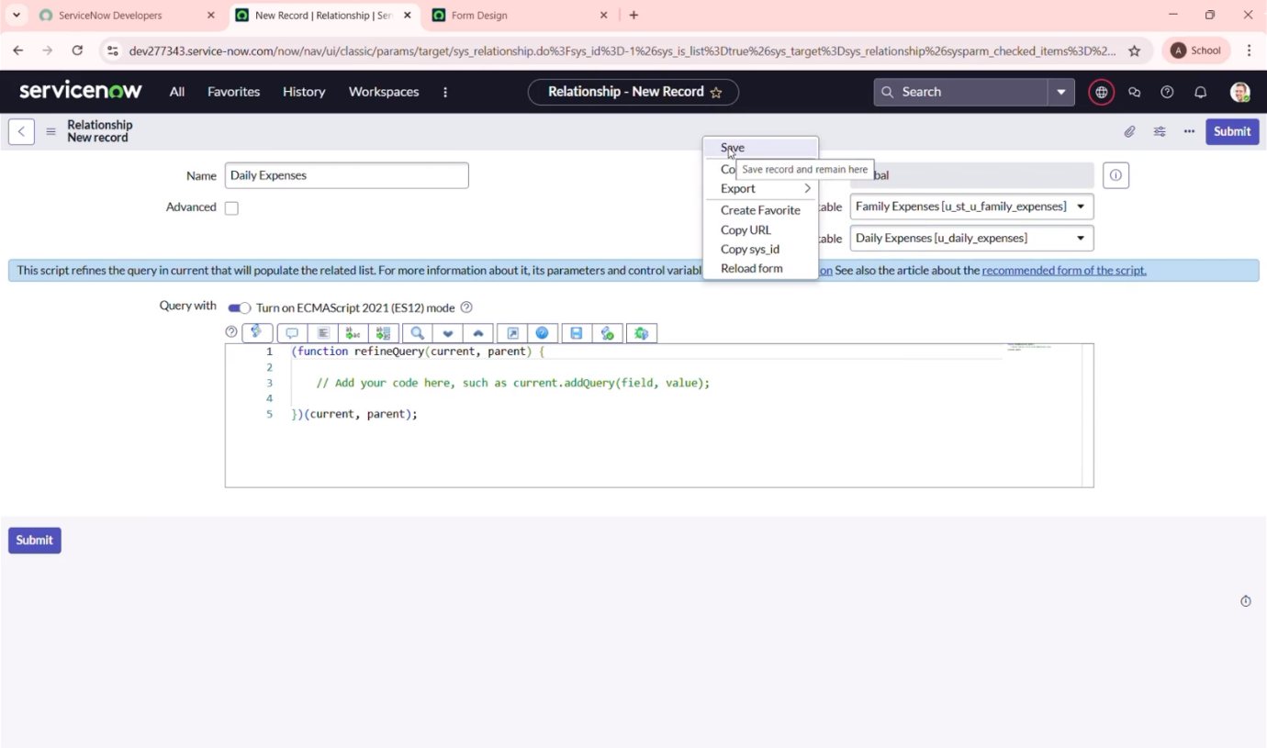

**Configuring Related list on family expenses**

Set up a related list in the family expenses form to view all liked daily expenses for easy reference

a. Go to all>>search “Family Expenses”>>open family Expenses

b. Click new >> configure

d. add Daily Expenses to the Selected area

e. Click on save

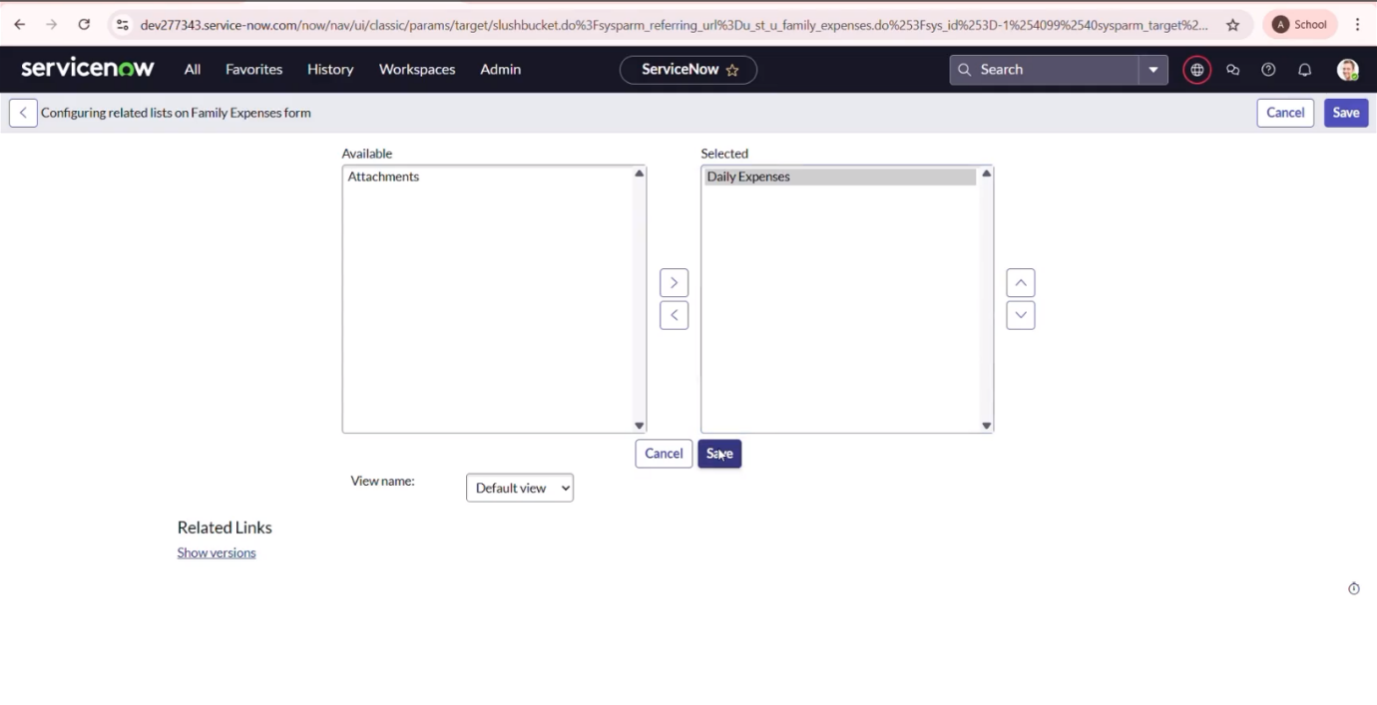

**Creation of Business Rules**

Implemented business logic using Business Rules to automate tasks like field validations, updates, or notifications.

a. Go to all>>search>>Business Rules

b. Click new

c. Name : Family Expenses BR

Table : Select Daily Expenses

d. In when to run check insert and update

e. Write the code

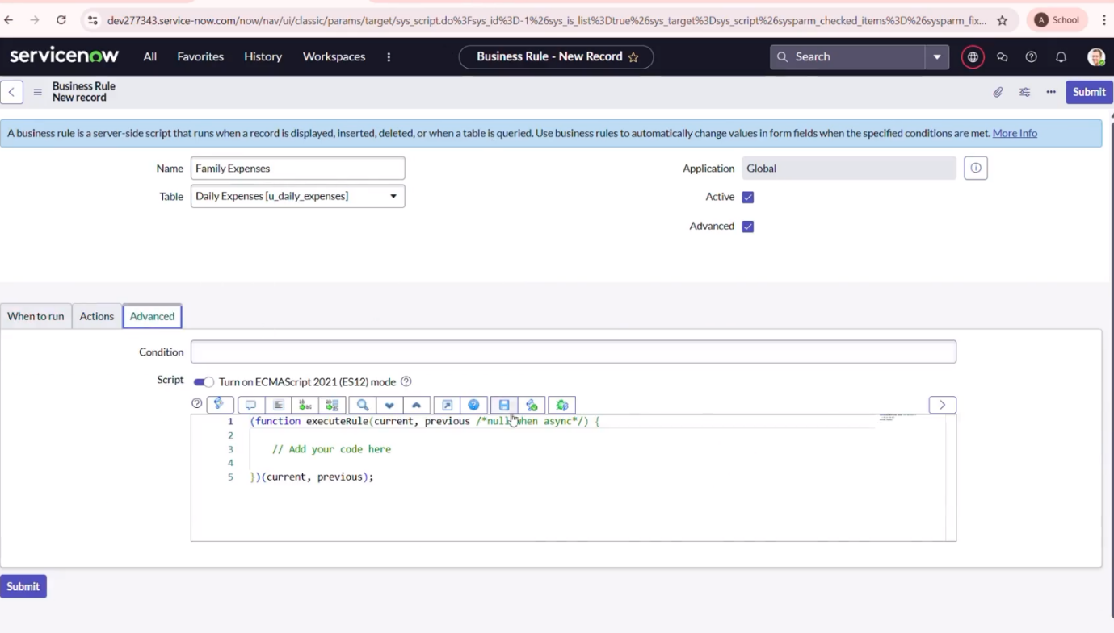

**Configure the Relationship**

Used ServiceNow’s dictionary setting to fine-tune the relationship (one–to–many) between the tables for accurate data linkage.

a. Go to all>>search>>open relationship

b. Open Daily Expenses Relationship

c. For applies to table : Select Family Expenses

d. In Query with

e. Click Update

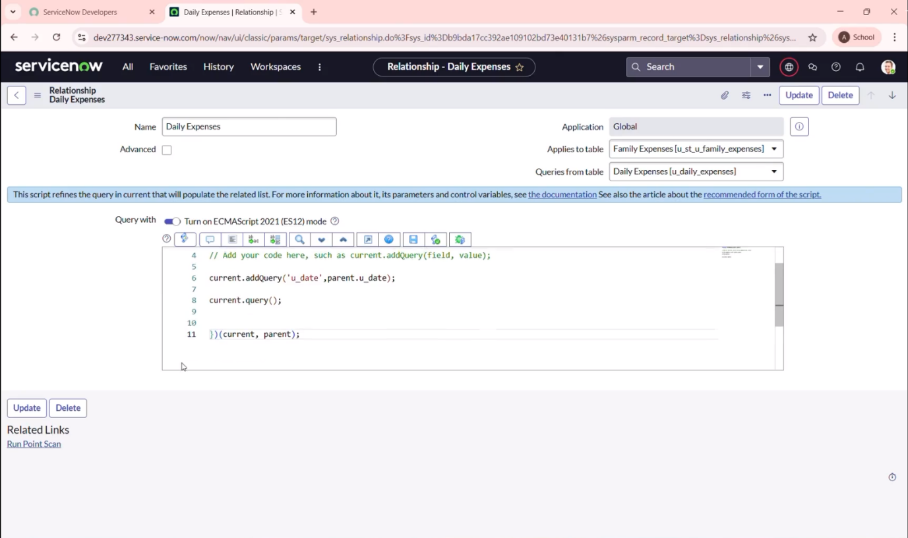

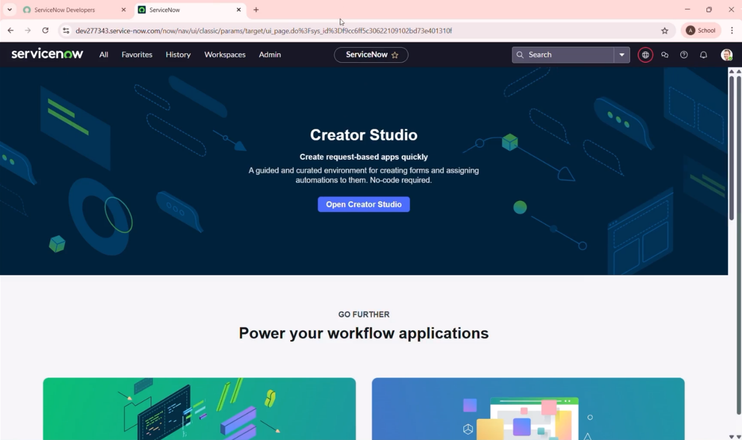

**Conclusion**

Used ServiceNow to implement and tested the end–to–end application and confirmed that it allows for efficient recording, tracking, and management of family expenses, providing users with a real–time financial overview.